HDFC BANK Audit Bill

SL NO | Date | Description | Amount
 | 06-11-2025 | Home to Dumdum (Cash) | 50
 | 06-11-2025 | Water Bottle (Cash) | 20
 | 06-11-2025 | Dumdum to Airport | 200
 | 07-11-2025 | Kolkata to Mumbai Ticket | 10197
 | 07-11-2025 | Water Bottle (Cash) | 20
 | 07-11-2025 | Mumbaito Kolkata Ticket | 8973
 | 08-11-2025 | Airport to Hotel | 405
 | 08-11-2025 | Dinner | 245
 | 08-11-2025 | Water Bottle (Cash) | 20
 | 08-11-2025 | Hotel | 1600
 | 08-11-2025 | Hotel to Dumdum | 220
 | 08-11-2025 | Dumdum to Home (Cash) | 50
Total = |  |  | 22000

07-11-2025
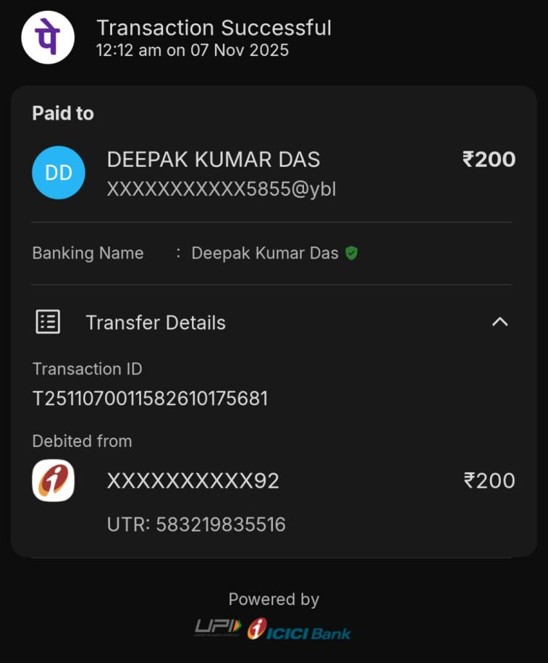
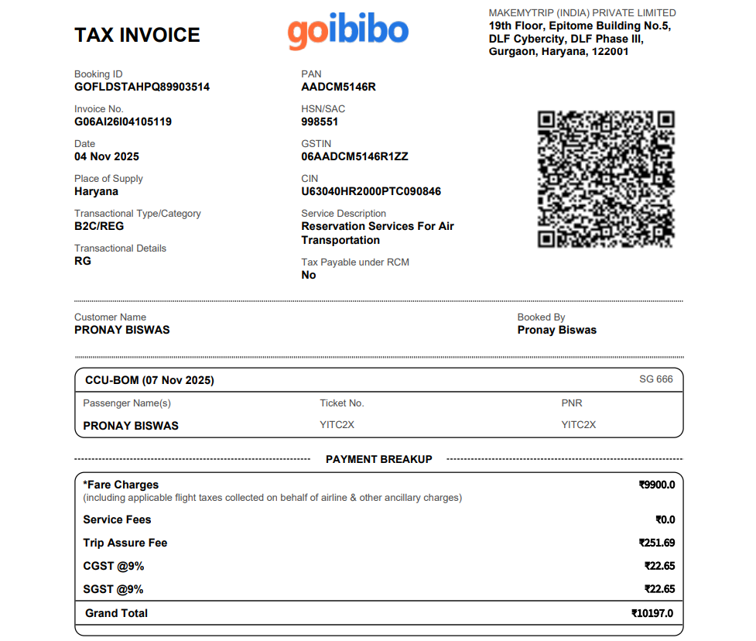
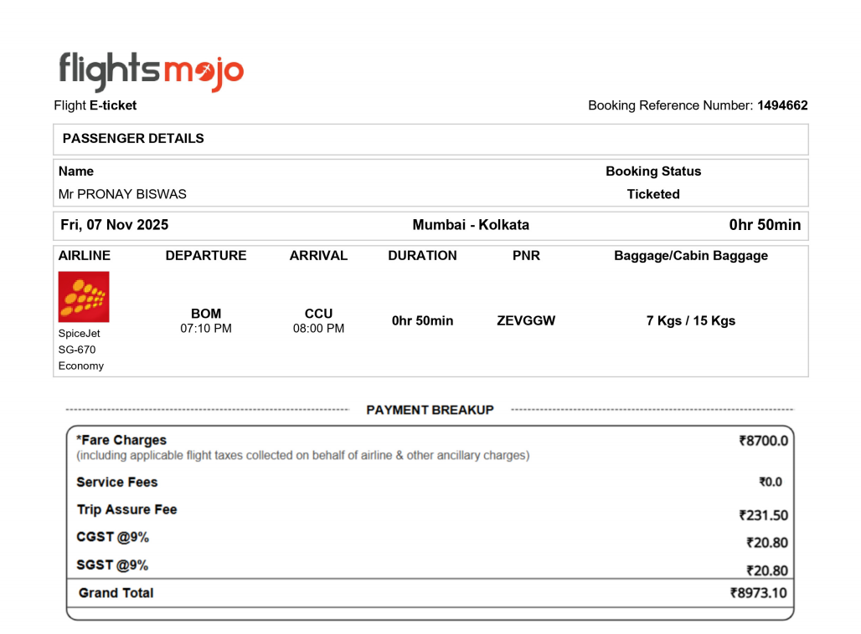
08-11-2025
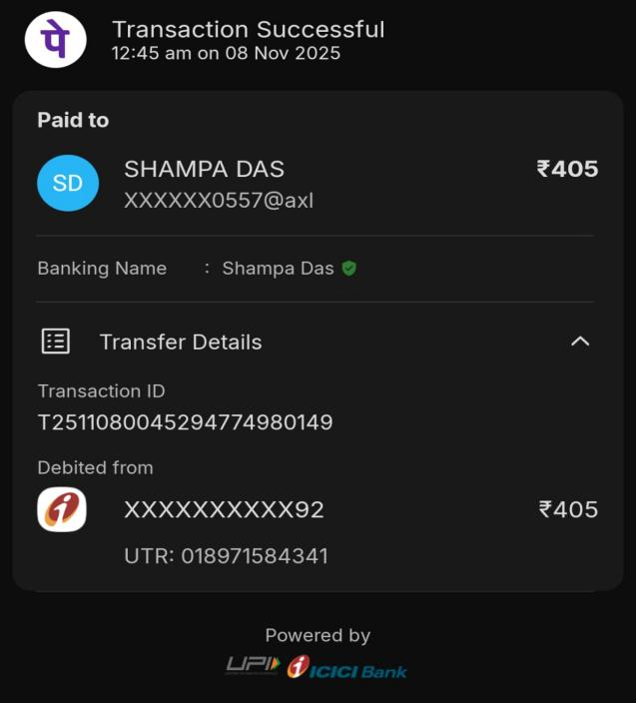 | 